Objective
In the present document will be described the services and equipment available in the different meeting rooms of the IAC as well as it's use, operation and connections to ease fixing any issue.

Content Index
Índice de contenidos
Inventario de equipos-servicios
Equipos
AULA
Sala Trífida
Sala Omega
Sala 1 Biblioteca
Sala 2 Biblioteca
Sala 3 Biblioteca
Sala GTC
Sala Pleyades
Sala Burbuja
Servicios
Aula
Sala Trífida
Sala Omega
Sala1 Biblioteca
Sala2 Biblioteca
Sala3 Biblioteca
Sala GTC
Sala Pléyades
Sala Burbuja
Esquemas de conexiones
Aula

Services-Equipment Inventory

Equipment

AULA

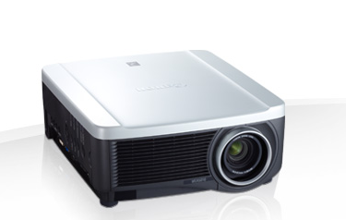 | Beamer  Format 16:10  Native resolution 1920 x 1200  Brightness 6000 lumens  Contrast relation 2000:1
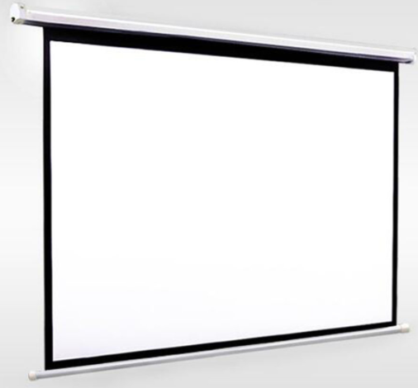 | Powered Screen  Powered, big format, wall mounted. 530x300cm  Reinforced aluminium box  Facing cloth with 0,6mm of thickness, opaque on backface  Gain 1,2, Clasification M-1
Laptop
Dell Latitude e6430
Intel Core I5
8 gb Ram
320 gb HDD space
14” Screen with resolution 1366 x 768
Vga / Hdmi connection 1920 x 1080
Wifi
DVD
Presenter
Presenter Logitech R400 with red laser pointer.

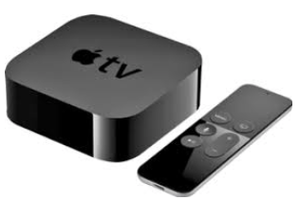 | Apple TV  HDMI 1.43  Wi‑Fi 802.11ac MIMO  Ethernet 10/100Base-T  Bluetooth 4.0  Infrared receptor
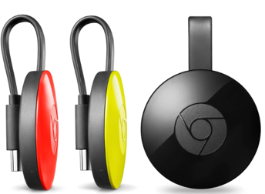 | Chromecast  Compatible with HDMI y CEC  Maximum display output resolution  1080p HDMI  Wi-Fi Standards  802.11 b/g/n/ac (2.4 GHz o 5 GHz)
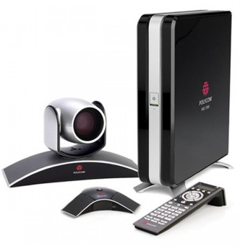 | Videoconference  Cámara EagleEye™, 720p o 1080  HDX microphones  Cables and remote controller  Connections  H.264 / H.263++/ H.261/ H.234
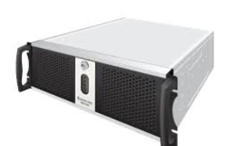 | Streaming Epiphan  Capture at 2K resolutions (2048×2048 or 2560×1600 wide screen)  4-card or 6-card versions depending on number of sources you have  Each card has 1 HD (VGA/DVI/HDMI) port and 1 SDI (3G, HD and SD) port andone SD (S-Video) port, capture from all at once

Trífida Room

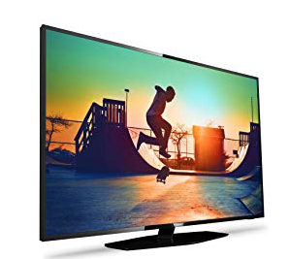 | TV  42” TV with VGA and HDMI connections

Omega Room

Powered Screen
Powered, big format, wall mounted. 230x200cm
Reinforced aluminium box
Facing cloth with 0,6mm of thickness, opaque on backface
Gain 1,2, Classification M-1
TV
42” TV with VGA and HDMI connections

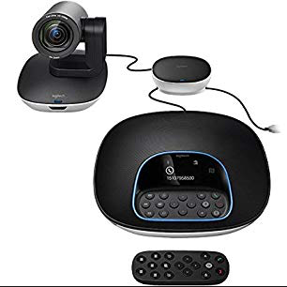 | Videoconference  Zoom and Jabber connections  H.264 / H.263++/ H.261/ H.239
Beamer
Format 16:10
Native resolution 1920 x 1200
Brightness 2000 lumens
Contrast relation 2000:1

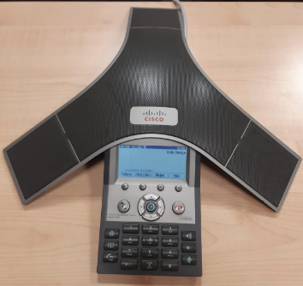 | Teleconference  Conference cisco phone with speaker.

Room 1 Library

TV
65” TV with VGA and HDMI connections

Room 2 Library

TV
65” TV with VGA and HDMI connections

Room 3 Library

TV
65” TV with VGA and HDMI connections

GTC Room

Powered Screen
Powered, big format, wall mounted. 230x200cm
Reinforced aluminium box
Facing cloth with 0,6mm of thickness, opaque on backface
Gain 1,2, Classification M-1
TV
42” TV with VGA and HDMI connections

Videoconference
Zoom and Jabber connections
H.264 / H.263++/ H.261/ H.239

Beamer
Format 16:10
Native resolution 1920 x 1200
Brightness 2500 lumens
Contrast relation 2000:1

Teleconference
Conference cisco phone with speaker.

Pleyades Room
TV
80” TV with VGA and HDMI connections

TV
42” TV with VGA and HDMI connections

Videoconference
Zoom and Jabber connections
H.264 / H.263++/ H.261/ H.239

Apple TV
HDMI 1.43
Wi‑Fi 802.11ac MIMO
Ethernet 10/100Base-T
Bluetooth 4.0
Infrared receptor
Chromecast
Compatible with HDMI y CEC
Maximum display output resolution
1080p HDMI
Wi-Fi Standards
802.11 b/g/n/ac (2.4 GHz o 5 GHz)

Teleconference
Conference cisco phone with speaker.

Burbuja Room

Powered Screen
Powered, big format, wall mounted. 230x200cm
Reinforced aluminium box
Facing cloth with 0,6mm of thickness, opaque on backface
Gain 1,2, Classification M-1
TV
42” TV with VGA and HDMI connections

Videoconference
Zoom and Jabber connections
H.264 / H.263++/ H.261/ H.239

Beamer
Format 16:10
Native resolution 1920 x 1200
Brightness 2500 lumens
Contrast relation 2000:1

Servicios

Aula
Beamer. - HDMI and VGA input and a screening display. Laptop with Windows for the presentations
Videoconference. - Polycom videoconference system. Allows H323 protocol.
Streaming.- El servicio de Streaming dispone de una cámara de video sony y de un servidor de Streaming Epiphan Standalone VGA.
Streaming.- The streaming service have available a Sony videocamera and a Streaming Epiphan Standalone VGA server. Allow live restransmition in internet/intranet and/or the record of the meeting, seminars, talks. Also include it publishment in http://iactalks.iac.es/

Trífida Room
Projection. - 42” TV with VGA input
Teleconference. – Cisco teleconference system

Omega Room
Screening. - HDMI and VGA input and a screening display.
Videoconference. - Logitech videoconference system. Allows h323, Zoom and Jabber.
Teleconference. – Teleconference Cisco phone.

Library Room 1
Projection. - 65” TV HDMI and Dport inputs (VGA with adapter that it’s in the CAU).

Library Room 2
Projection. - 65” TV HDMI and Dport inputs (VGA with adapter that it’s in the CAU).

Library Room 3
Projection. - 65” TV HDMI and Dport inputs (VGA with adapter that it’s in the CAU).

GTC Room
Projection. - Beamer with HDMI, VGA inputs and screening display.
Videoconference. - Polycom videoconference system. Allows H323 protocol.
Teleconference. – Teleconference Cisco phone.

Pléyades Room
Projection. – 80” TV with HDMI, VGA inputs.
Videoconference. - Logitech videoconference system. Allows h323, Zoom and Jabber.
Teleconference. – Teleconference Cisco phone.

Burbuja Room
Projection. - Beamer with HDMI, VGA inputs and screening display.
Videoconference. - Polycom videoconference system. Allows H323 protocol.
Teleconference. – Teleconference Cisco phone.

Connections scheme

Aula
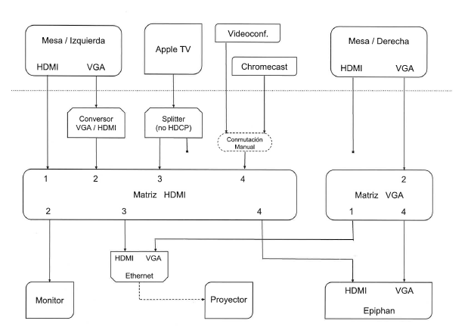
Inputs
- VGA Connection
- HDMI Connection
- Apple wireless connection for Mac OS and IOS
- Chromecast wireless connection for Windows and Android
- Sony video camera
- All connections support till 1920x1080 screen resolution
Outputs
- Beamer y Streaming: support till 1920x1080 screen resolution
- Videoconference Polycom resolution 720p

